Open the "Foodmart_Data_Model.xlsx" worksheet that you saved on your desktop. This file was the finished product of your previous exercise. You should complete first all the other exercises and Quest before this one.

You should see all tables loaded under Data > Queries & Connections

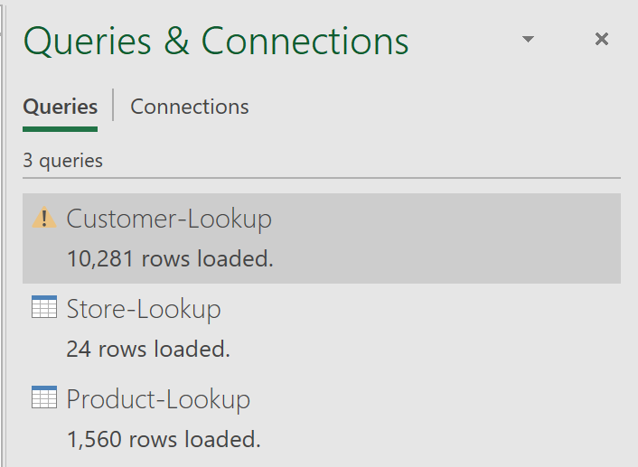



Now let's load our fourth file, the Calendar-Lookup.csv. Click Data, arrow-down of Get Data, From File, From Text/CSV

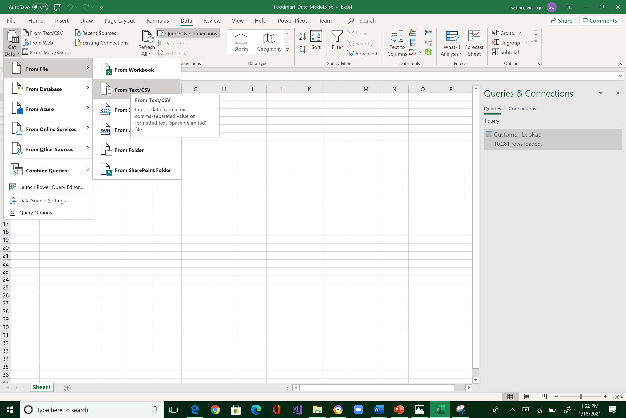



Navigate to where you store "FoodMart Data" (the files that you downloaded from Canvas last week) and select "Calendar-Lookup.csv".

You will see the import preview interface below. This is the window where we do data shaping, filtering, and transformation. From here, by default, you would always want to select Transform Data. So, click it!

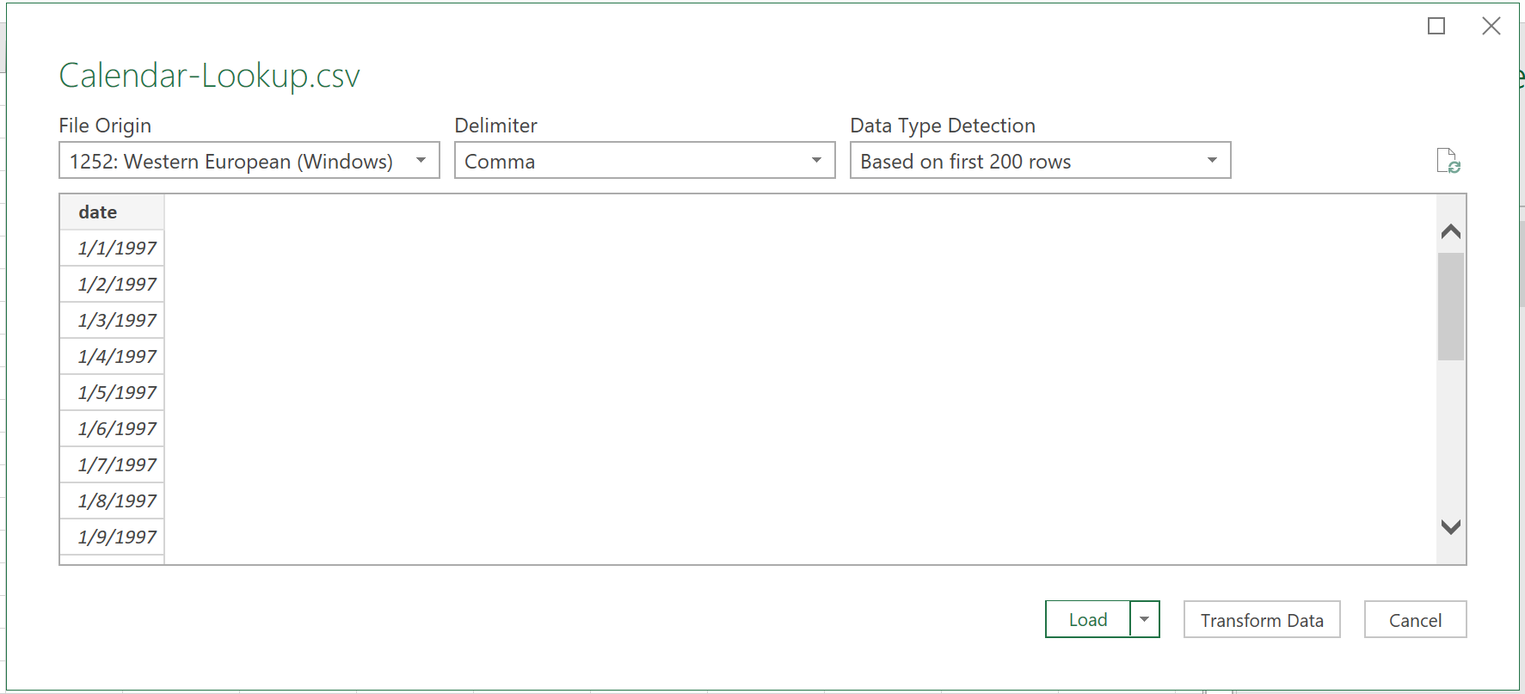



Same process:

1. Check the table name
2. Check if the column headers is what you want
3. Check the data types per column

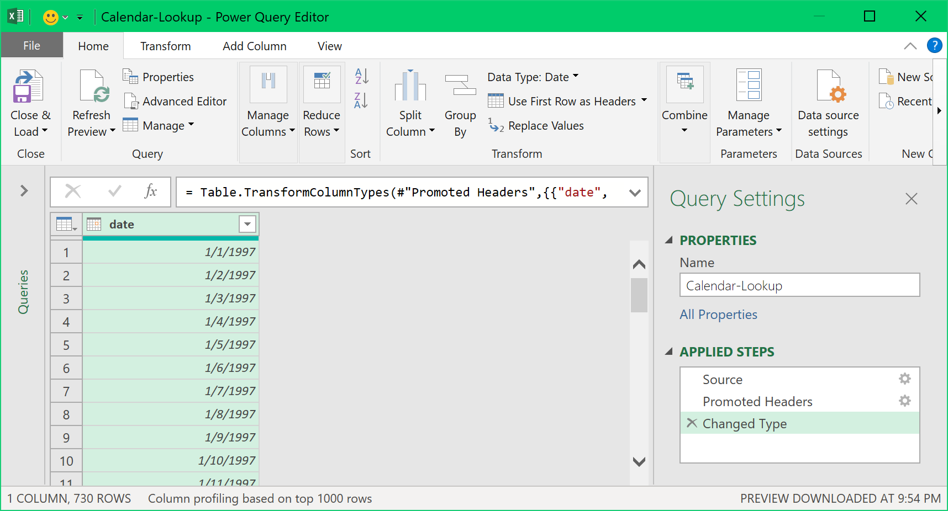

While the date column is highlighted, select Transform, Date, Earliest.

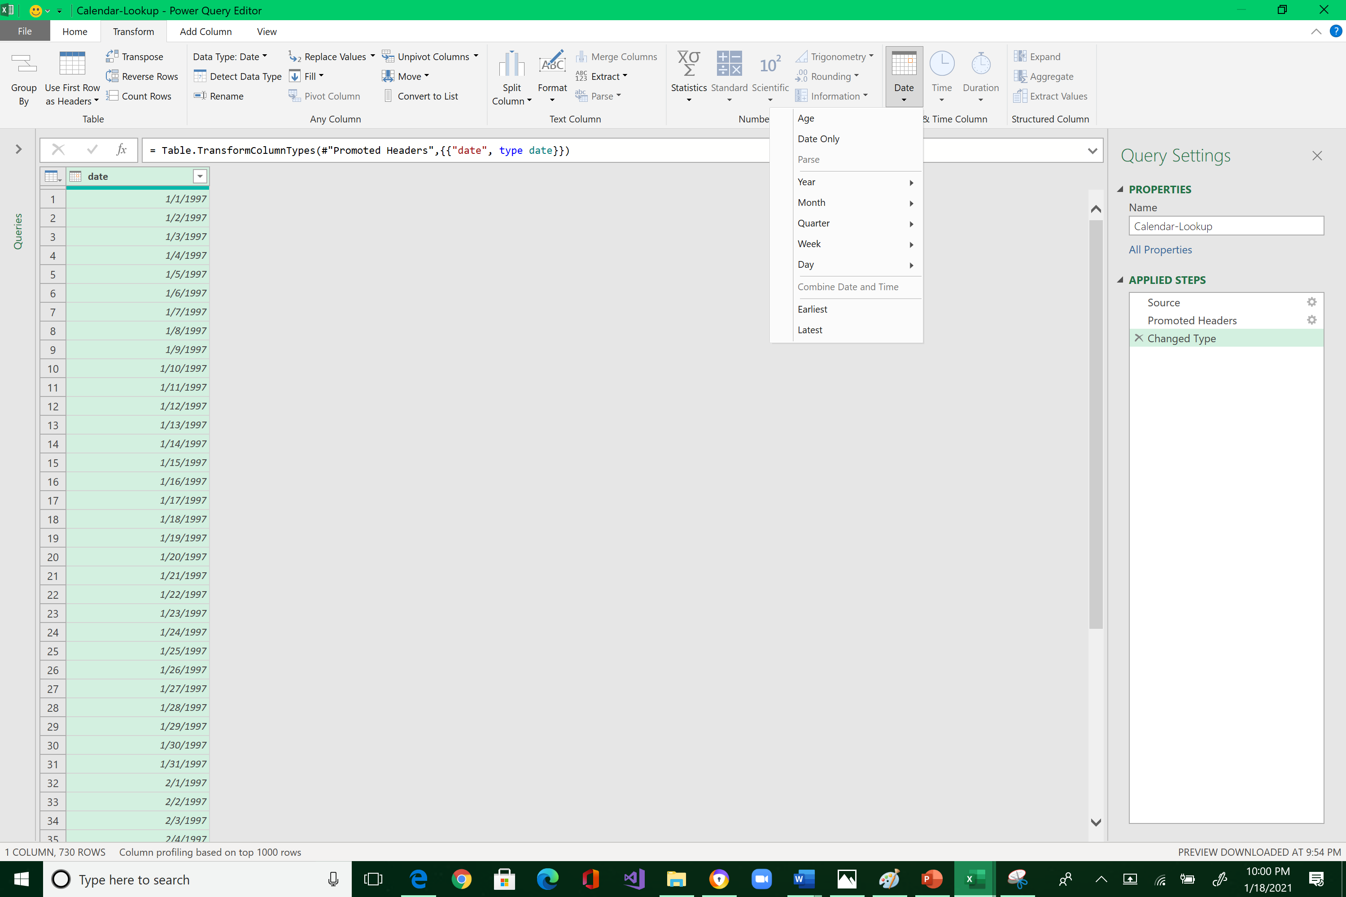



It should yield 1/1/1997

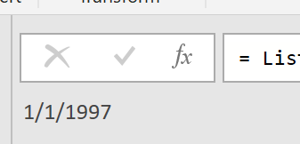

Delete this step because this is just an exploratory process. This will bring you back to the Power Query Editor.

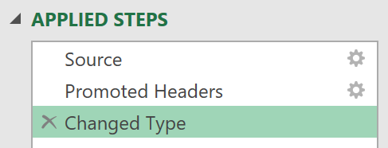



Find also the Latest date: it should yield: 12/31/1998

Make sure you delete the last step you did in order to go back to Power Query Editor

Also, if the Latest function is not enabled, you may have to discard the Power Query Editor, and reload the Calendar-Lookup.csv

Now, let’s build our calendar. Add Column > Date > Year > Year

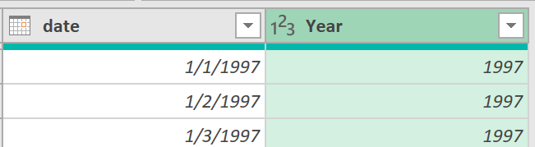



Note that a Year column is inserted.

Click on the arrow-down to determine the values in this column. There are two values 1997 and 1998. Then click OK.

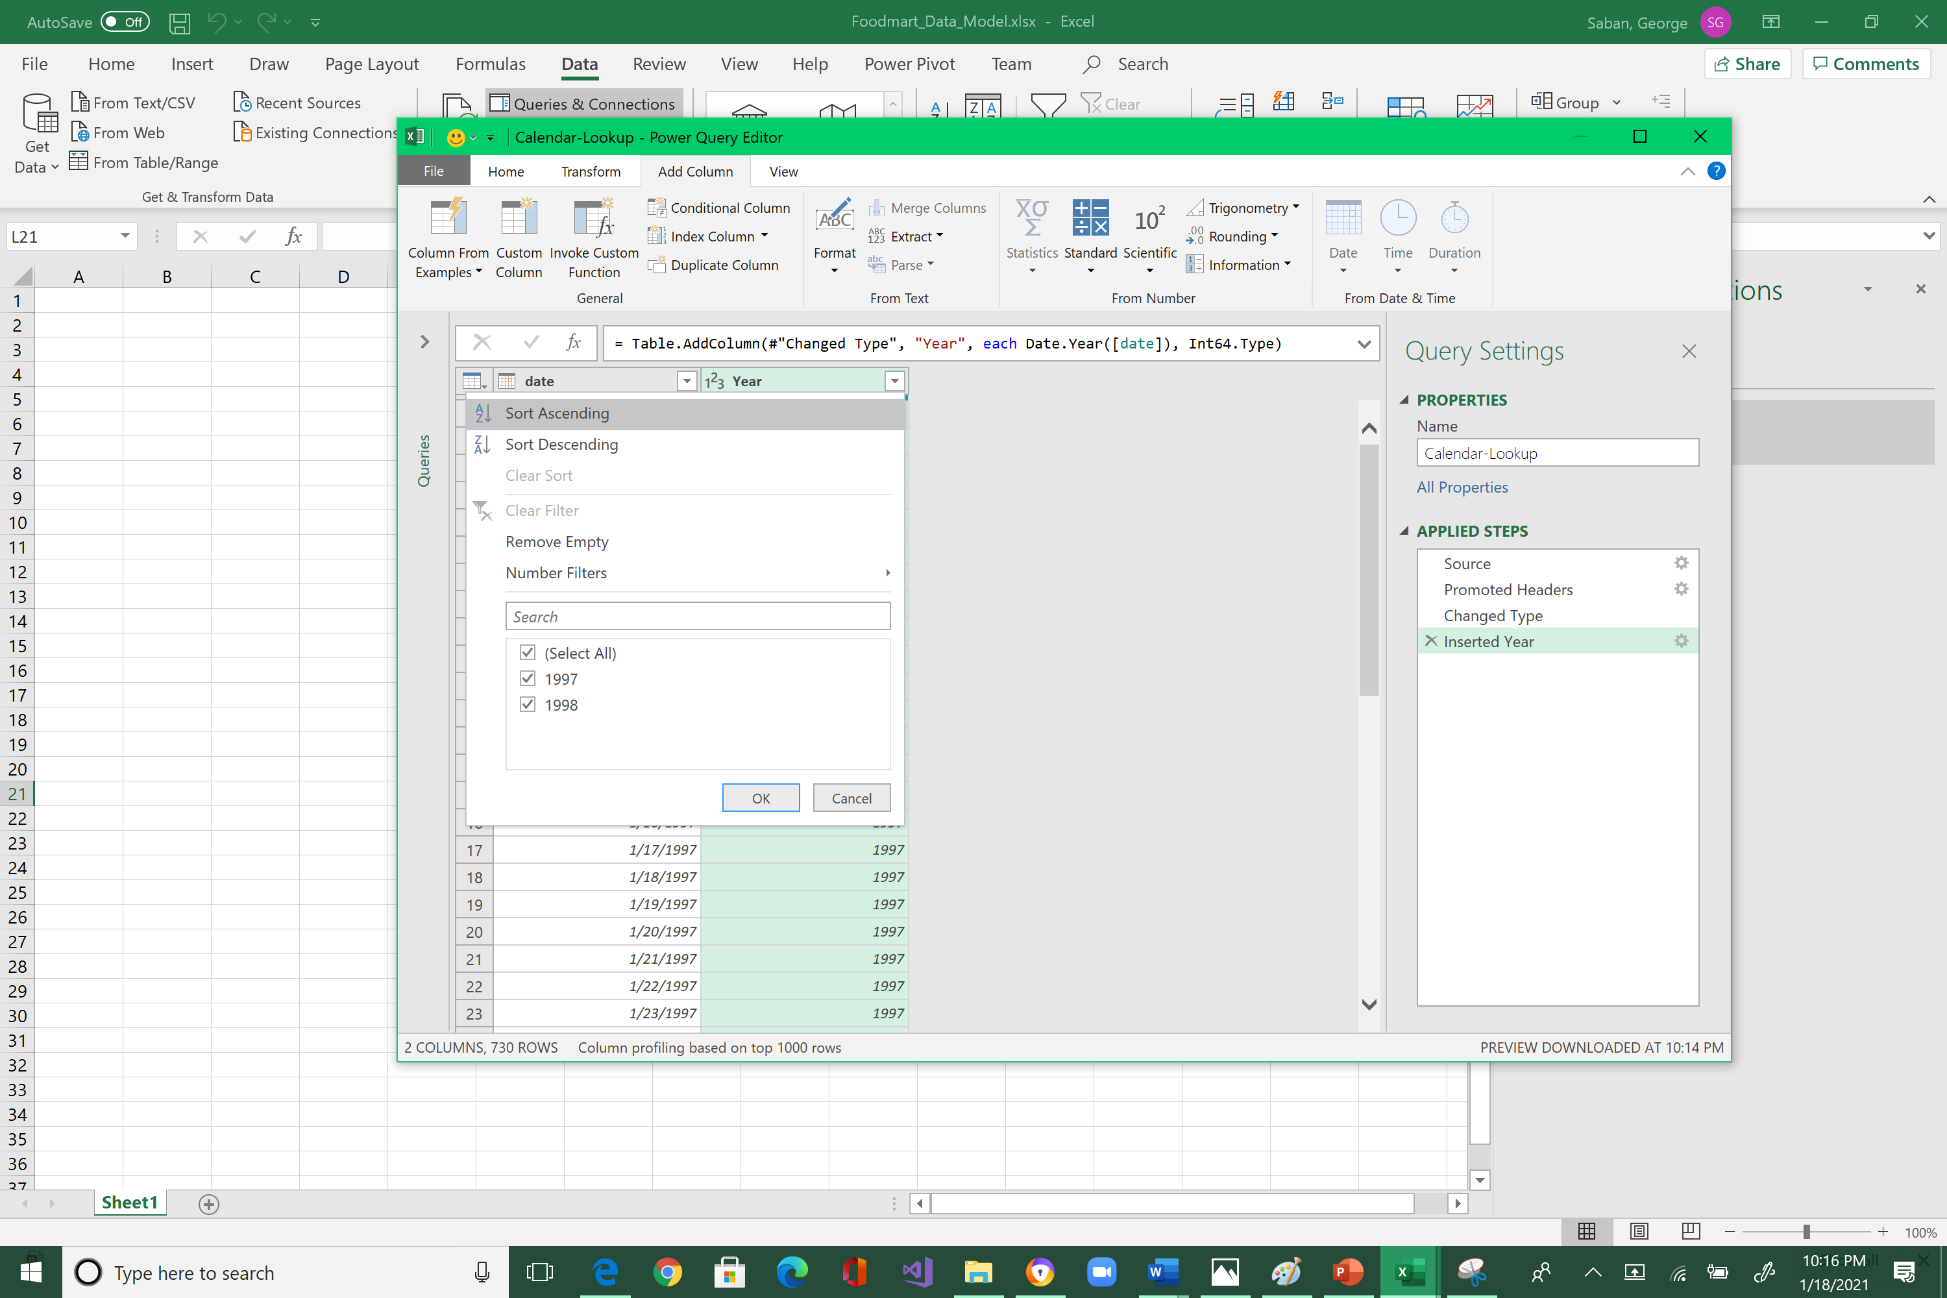



To build the months column, you have to reselect the date field again, Add Column > Date > Month > Month

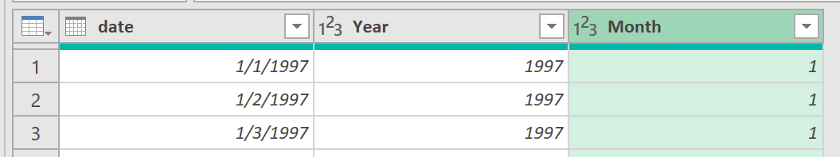



Click on the arrow-down next to the Month column to show all its possible values. Then click OK.

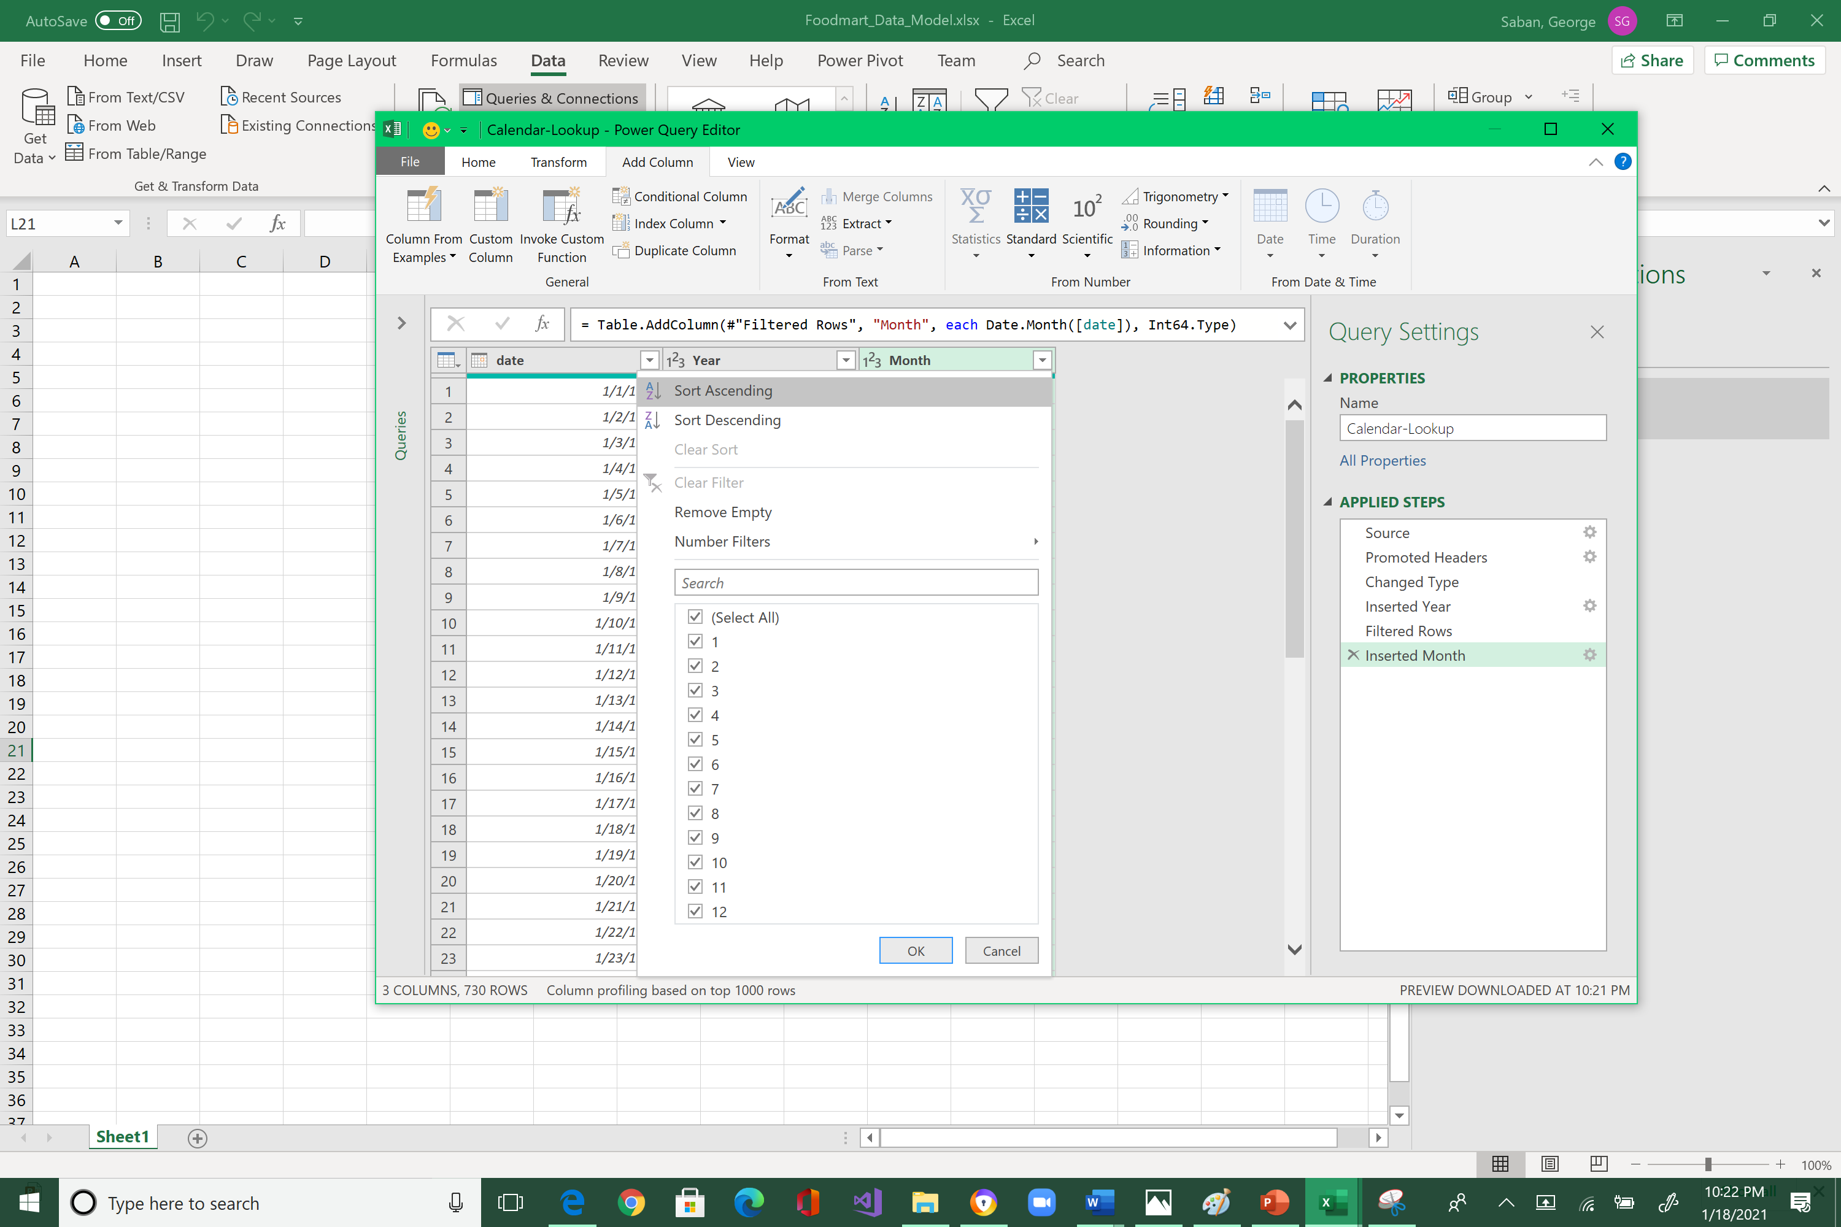



Now, create the name of the month. Highlight date column > Add Column > Date > Month > Name of Month

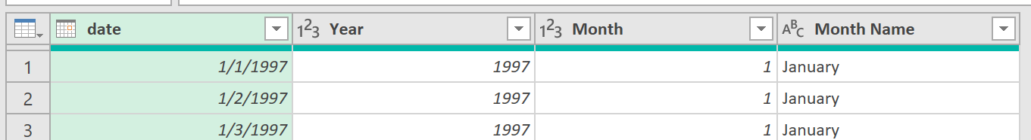



Now, create the quarter of the year. Highlight date column > Add Column > Date > Quarter > Quarter of Year

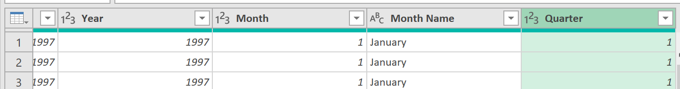



Now, create the week of the year. Highlight date column > Add Column > Date > Week > Start of Week





Power Query decides that the start of the week is a Sunday. So, to change the start date, you can alter the ‘M’ code by adding , Day.Monday





This change will modify the definition of a week to start on a Monday instead of Sunday.





Now, create the day of the year. Highlight date column > Add Column > Date > Day > Day

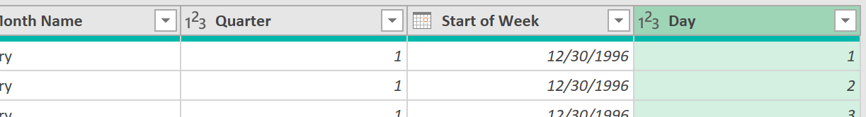



Now, create the name of the day. Highlight date column > Add Column > Date > Day > Name of Day

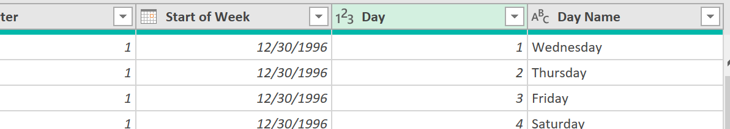



Note how the one-column table was transformed into a more comprehensive calendar table!

It is now time to load this data. Click the Home tab. It is very important that you select the small arrow-down icon next to the Close & Load, and not the Close & Load button. Please redo your work if you make this mistake.

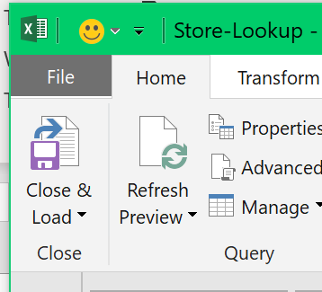



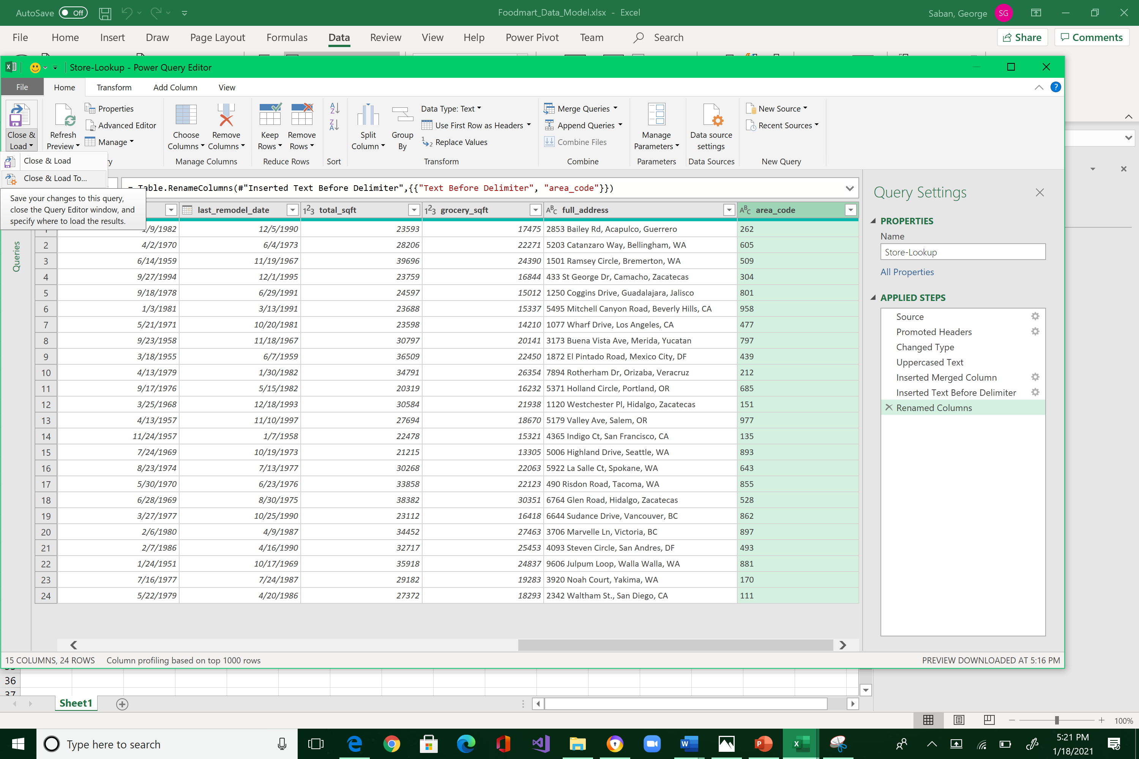



Select “Only Create Connection,” and “Add this data to the Data Model” options inside the Import Data window. Click OK.

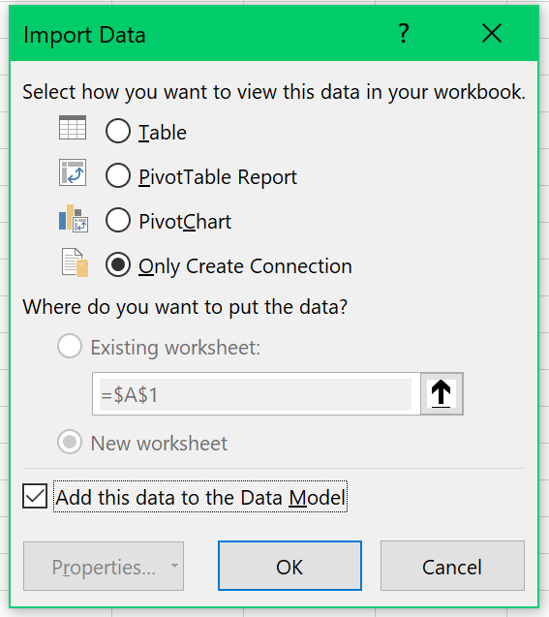



Note the 730 rows loaded into the Data Model.

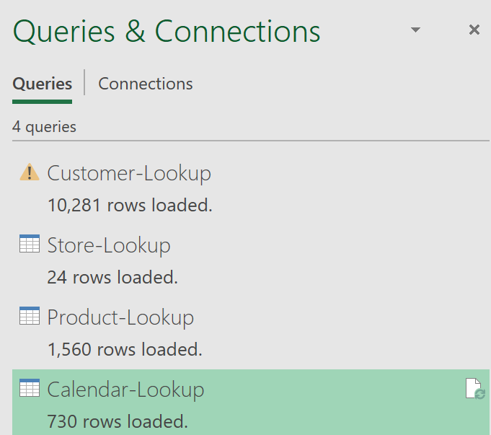



To verify your new table, click Power Pivot, Manage

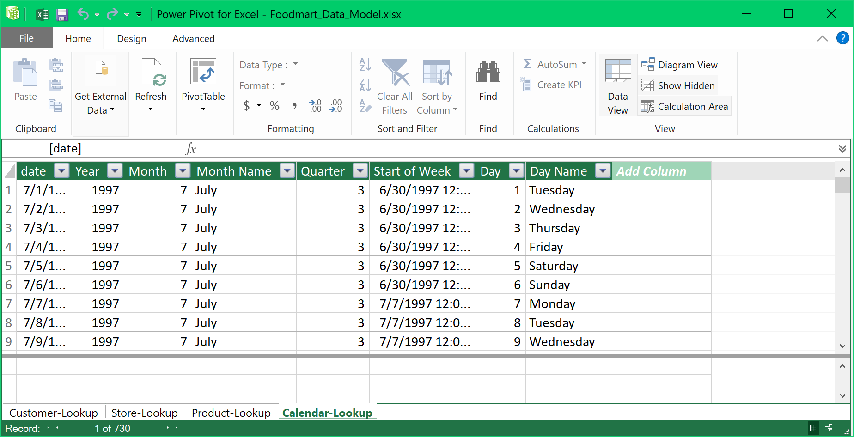



Make sure that the changes are applied.

Save your work by closing the Data Model screen and go back to Excel. Click File, Save.

After you save your work:

1. Resize the Excel spreadsheet and take a snapshot using Window's Snipping Tool.
2. Make sure the system's date, your name, and the number of rows loaded are included in the image.
3. Submit to Canvas in PNG format.

